**COUNTY LOGO   
GOES HERE**

**[NAME] COUNTY FARM BUREAU**

THE VOICE OF AGRICULTURE

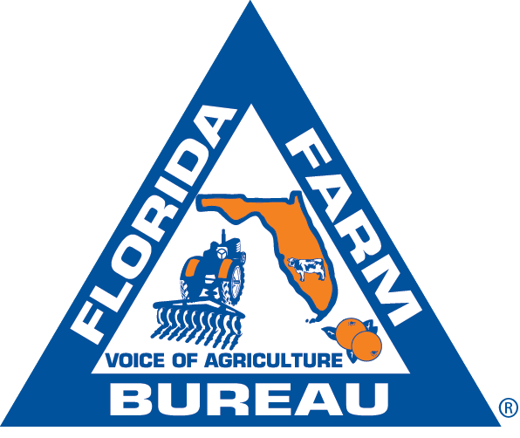

**FOR IMMEDIATE RELEASE**

**[Date]**

**Media contacts:**

(Name, Title)

(Phone)

(Email)

**[County Farm Bureau] to Sponsor Farm City Week Event on [Date]**

**City, Fla. –** Farm-City Week will be celebrated this year from Nov. 19 through Nov. 26. It is a week to recognize the vital partnerships between rural and urban communities that make our food supply safe and plentiful.

____________ County Farm Bureau will sponsor [activity] during Farm-City Week to recognize the contributions of Farm-City relationships.

Here in ___________County, agricultural businesses include: [list types of agriculture in county], supporting [number] jobs and contributing [$X amount] annually to the local economy.

From the field to the table, agriculture is a team effort. Farmers, ranchers, processors, truckers, shippers, advertisers, retailers and consumers all play a role in ensuring a safe and abundant food supply.

Farmers and ranchers depend on urban partners to supply, sell and deliver the food, fiber and fuel that support our daily lives. In turn, consumer demand and urban infrastructure make sustainable agriculture possible.

These collective efforts also conserve freshwater resources, wildlife habitats and greenspace.

For more information about Farm-City Week activities in our local community, please contact [Name] at the [County] Farm Bureau at [number or email].

[County] Farm Bureau is affiliated with the Florida Farm Bureau Federation, the state’s largest general interest agricultural organization, representing *more than 133,000 member-families. Florida Farm Bureau serves to enhance farm enterprise and improve rural communities.*

*###*

*\*\* Please refer to the USDA Census of Agriculture for detailed information about your county on farmland size and market crop value: Census of Agriculture - 2022 (usda.gov).*

*Please refer to the UF|IFAS Extension Economic Contribution Reports by County.*